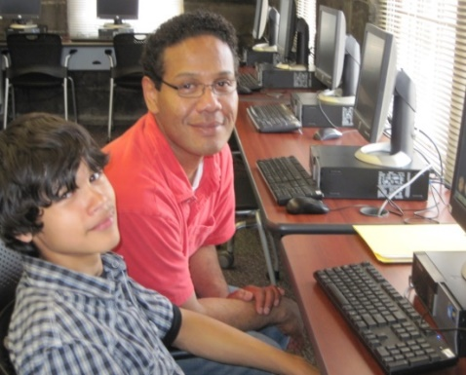

UNI-CUE TUTORING CENTER
HANDBOOK FOR PARENTS

The UNI-CUE Tutoring Center is a University of Northern Iowa Program.

PROGRAM OVERVIEW

The University of Northern Iowa Center for Urban Education (UNI-CUE) embraces a dual mission of learning and service. The UNI-CUE is located at 800 Sycamore Street in downtown Waterloo. The UNI-CUE’s mission is to provide a positive environment for lifetime learning where individuals may pursue and continue their educational goals and prepare for careers.
The UNI-CUE Tutoring Center established in 2009, is an outreach program serving Black Hawk County students in grades K-12. The learning environment at the Tutoring Center is success oriented and offers opportunities for learners to succeed academically, increase their self-esteem, and become more productive citizens within their community.
Tutoring consists of one-on-one sessions for one (1) hour each weekly session during the fall and spring semesters. All tutoring takes place at the UNI-CUE, 800 Sycamore Street in Waterloo, IA, on Monday, Tuesday, Wednesday, and Thursday evenings.

LOCATION

The UNI-CUE is located next to the Cedar River, on the corner of 6th and Sycamore Streets. The main entrance and parking lot are on the east side of the building. Parking is free in the UNI-CUE parking lot.

GENERAL GUIDELINES

Tutoring Schedule:
Mondays | Tuesdays | Wednesdays | Thursdays
4:00-5:00 p.m. | 4:00-5:00 p.m. | 4:00-5:00 p.m. | 4:00-5:00 p.m.
4:30-5:30 p.m. | 4:30-5:30 p.m. | 4:30-5:30 p.m. | 4:30-5:30 p.m.
5:00-6:00 p.m. | 5:00-6:00 p.m. | 5:00-6:00 p.m. | 5:00-6:00 p.m.
5:30-6:30 p.m. | 5:30-6:30 p.m. | 5:30-6:30 p.m. | 5:30-6:30 p.m.
6:00-7:00 p.m. | 6:00-7:00 p.m. | 6:00-7:00 p.m. | 6:00-7:00 p.m.

Background Checks: The UNI-CUE requires Child Abuse Background Checks on all volunteers working with minors.

Waiting List: Tutoring appointments are made on a first-come first-served basis and upon the availability of tutors. Students may be placed on a waiting list until an appropriate tutor can be found to meet the specific needs of your child.

Attendance: Attendance is critical to the success of your child(ren) as they participate in the UNI-CUE Tutoring Center program. Our tutors do not receive payment for their time, nor do they receive reimbursement for the cost of transportation to the UNI-CUE. Therefore, you will be required to inform your tutor when your child will be unable to attend a tutoring appointment. In addition to calling your tutor, please report your child’s absence to 319-273-4772 as soon as possible before the schedule tutoring session.
NOTE: Students who miss two sessions per semester without a valid excuse may be dropped from the program.

Registration: Upon arrival at the UNI-CUE, parents and children do not need to register at the front desk, but are required to sign an attendance sheet in the Tutoring Center (2nd floor).

Child Drop Off and Pick Up: If someone other than the parent will be dropping off and/or picking up your child(ren), please call us at 319-273-4772. Parents/guardians must accompany their child(ren) to and from their tutoring sessions.

Cell Phone Usage: Cell phones and texting will not be allowed during tutoring sessions.
Confidentiality Statement: Information regarding participants participating in the UNI-CUE Tutoring Center program will be maintained with the strictest confidentiality.

UNI-CUE Contact Information: For additional information concerning the UNI-CUE Tutoring Center program, please call 319-273-4772.

COMMENTS FROM SATISFIED PARENTS

“Honestly, I don’t know how many parents … appreciate what your program has to offer. This program is an asset to (my child’s) schooling. As long as the program is available, we will continue to use it.”

“My fifth grade son has been in tutoring at the UNI-CUE for most of the school year. He looks forward to it every week. I just recently received his report card and every area was at a ‘3’ or better. This was very exciting for us because usually he is below average. I have noticed that his attitude about school has also improved. I would highly recommend this tutoring program to anyone.”

“This program does make a difference in children’s lives.”

“The UNI-CUE tutoring program is a wonderful opportunity for the children in our schools. The one-on-one teaching that the UNI tutors thoughtfully prepare each week to meet the needs of the students in their care provides academic support, encouragement, and aligns with the Waterloo Community School District's goals. The tutors gain valuable time learning how to design and implement lesson plans to meet the individual needs of their tutee. The tutee gains all the expertise and individual attention that the tutor has in their personal and academic experience. Both the tutor and tutee walk away from the experience knowing a little more about themselves, their education, and, hopefully, more confident in their abilities.”

For additional information about
the UNI-CUE Tutoring Center
program, please contact Bethany Jura.

